**DISK MANAGEMENT – II**

**LOGICAL VOLUME MANAGER(LVM):**

**WHAT IS LVM?**

* LVM stands for Logical Volume Manager, to resize file system’s size online we require LVM partition in Linux.
* Size of LVM partition can be extended and reduced using the lvextend & lvreduce commands respectively.

**Physical Volume:**

* It’s a raw hard drive that it initialized to work with LVM, such as /dev/sdb, /dev/sdc, /dev/sdb1 etc.

**Volume Group**:

* Many PV is combined into one VG. You can create many VGs and each of them has a unique name.

**Logical Volume**:

* You can create many LVs from a VG. You can extend, reduce the LV size on the fly. The LV also has unique names.
* You format the LV into ext4, zfs, btrfs etc filesystems, mount it and use it as you do other ordinary partitions.

**Partitions based Filesystem:**

* Hard Disks --> Partitions --> filesystem --> mount

**LVM based Filesystem:**

* Hard Disks --> Partitions --> Physical Volume --> Volume Group --> Logical Volume --> filesystem --> mount
* #lvmdiskscan

**CREATE LVM:**

* Add Hard Disks
* To list created disk 🡪 lsblk

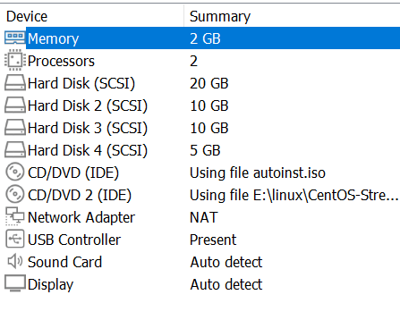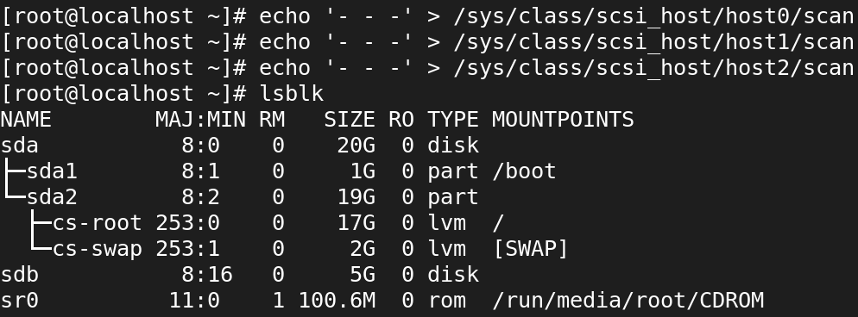

**CREATE PHYSICAL VOLUME:**

* pvcreate /dev/sdb



**LIST PV DETAILS:**

* pvs

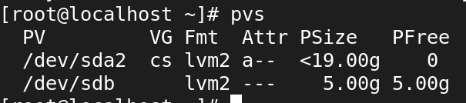

* pvdisplay

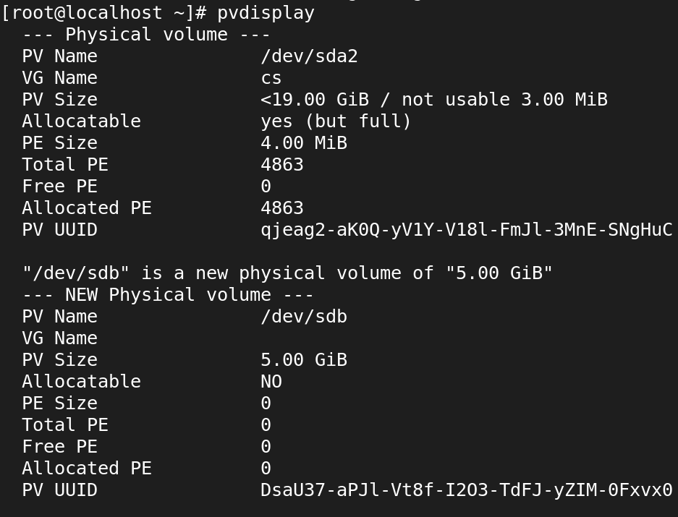

**CREATE VOLUME GROUP:**

* vgcreate lvg /dev/sdb

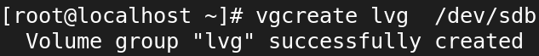

**LIST VOLUME GROUP:**

* vgs

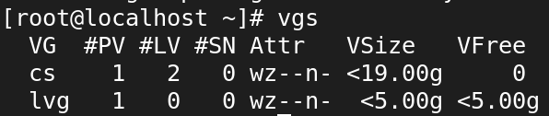

* vgdisplay

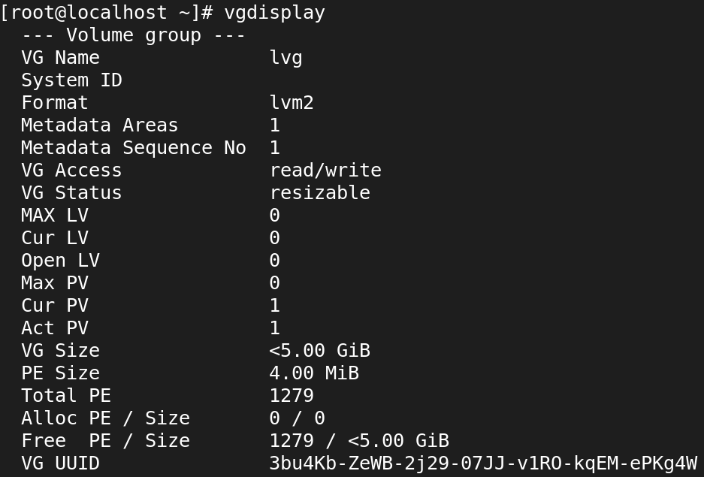

**TO EXTEND THE VOLUME GROUP:**

* vgextend lvg /dev/sdc

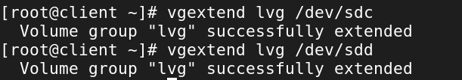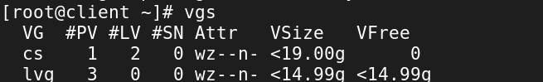

**CREATE LOGICAL VOLUME:**

* lvcreate -L +5G -n lvgl lvg

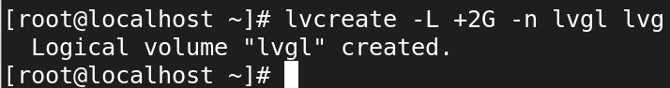

**TO LOGICAL VOLUME:**

* lvs

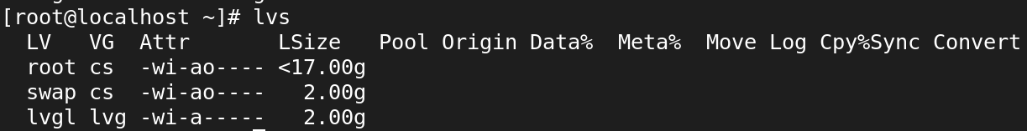

* lvdisplay

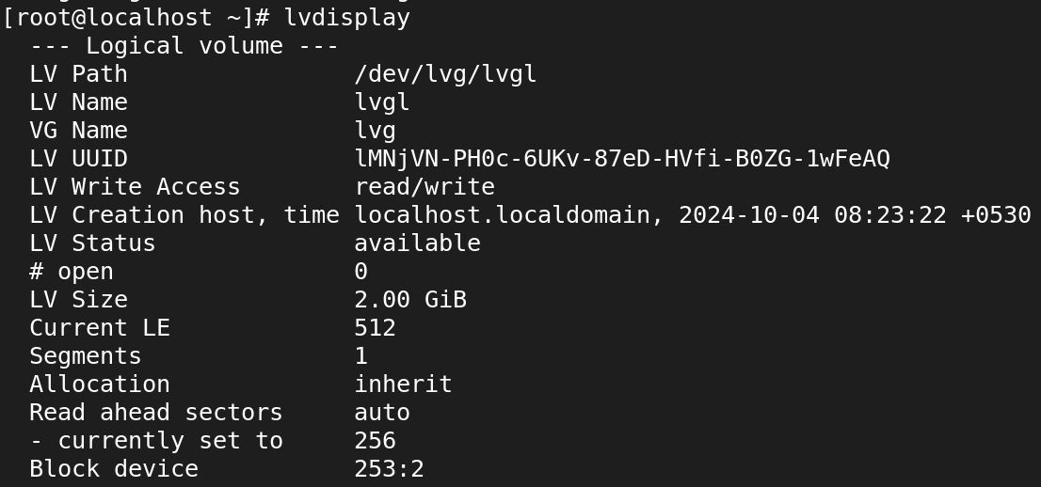

**CREATE FILESYSTEM:**

* mkfs.xfs /dev/lvg/lvgl

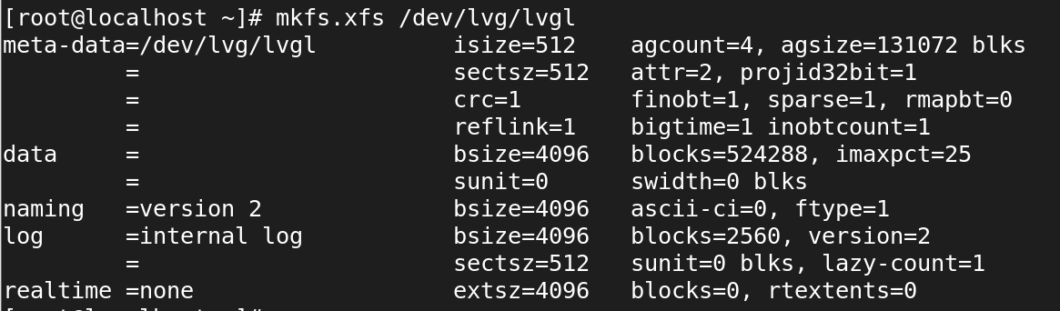

**TEMPORARY MOUNT:**

**Mount The Filesystem:**

* mkdir /arun



* mount /dev/lvg/lvgl /arun

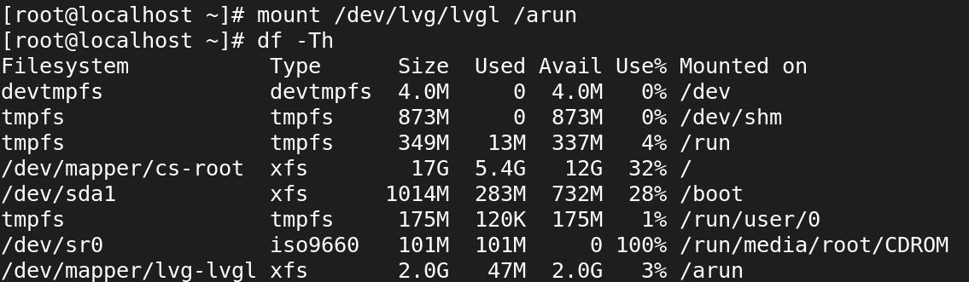

**COMMAND TO CHECK MOUNTED FILESYSTEM:**

* df -h

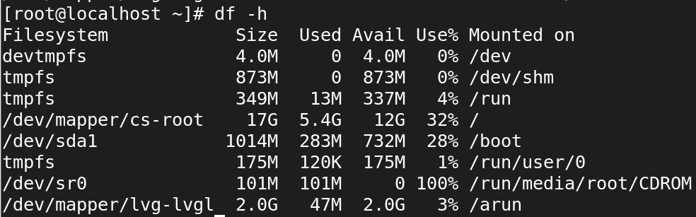

**Create files in the mounted dir:**

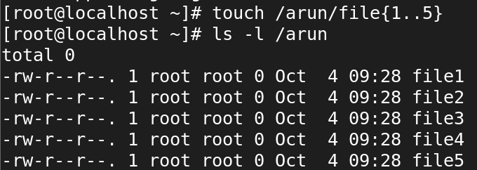

In temporary mounting, all files have deleted after rebooting:

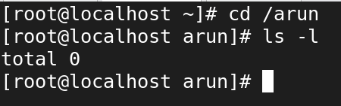

**PERMANENT MOUNT:**

* vi /etc/fstab

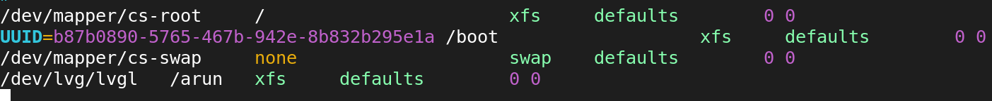

**In permanent mounting, all files have presented after rebooting**

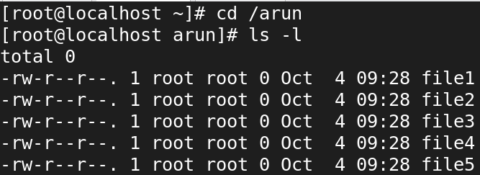

**To extend the size lvgl:**

* lvextend -L +2G /dev/lvg/lvgl

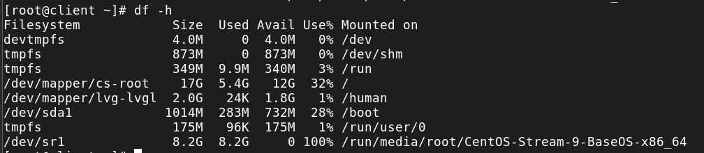

**Remove LVM:**

Remove fstab entry first 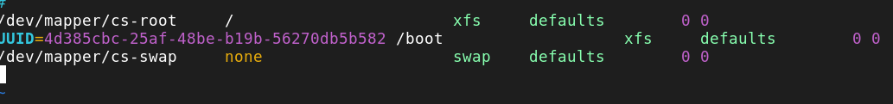

**Unmount the directory:**

* umount /kavin

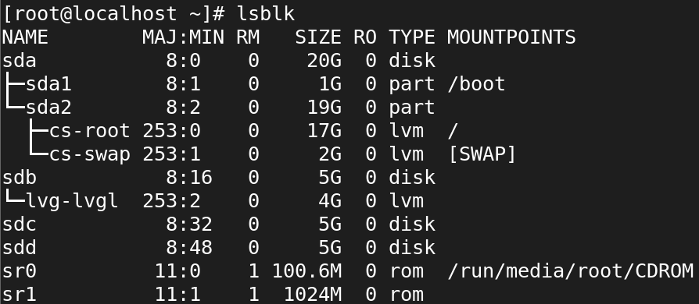

**Remove the logical volume:**

* lvremove lvg



Remove the volume group:

* vgremove lvg

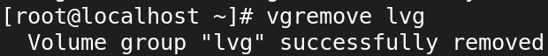

Remove the Physical volume:

* pvremove /dev/sdb
* pvremove /dev/sdc
* pvremove /dev/sdd

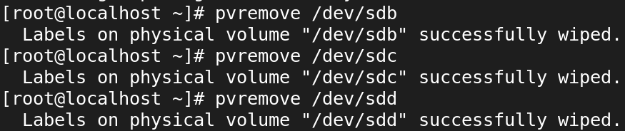

* lsblk

